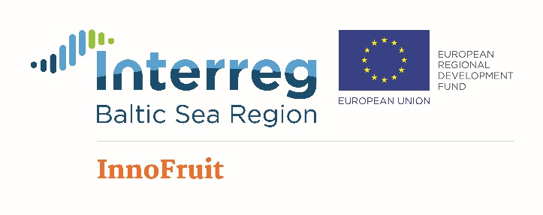
Advancement of non-technological innovation performance and innovation capacity in fruit growing and processing sector in selected Baltic Sea Region countries

Programme of Polish experts and Fruit Growers Visit to Lithuania
August-20-22 2018

20.08.2018 – Monday

Afternoon. Arrival to Lithuania.

Visit of Kvedaraitė sea buckthorn farm near Alytus (Venciūnai) (plantations, propagation, harvesting, processing, products).

21.08.2018 - Tuesday

9:00 Travel from Kaunas

10:30 – 11:30 Visit of R.Urbonavičius apple farm Naujamiestis, Panevėžys distr. (47 ha apples, mechanical pruning)

12:30 – 13:30 Lunch (Biržai)

13:45 – 14:30 Visit of R.Rinkevičius apple farm Parovėja, Biržai distr. (40 ha apples, mechanical harvesting)

15:00 – 16:30 Visit of Naradava fruit growing company Pajiešmeniai, Pasvalys distr. (300 ha apples, processing).

18:30 Arrival to Kaunas

22.08.2018 - Wednesday

9:00. Visit of the Institute of Horticulture, Babtai
(incl. visits of orchards and processing unit).

11.30 Lunch

12.30 Travel to Latvia

