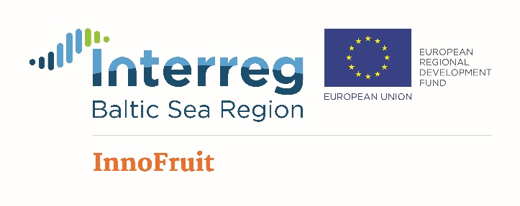
Advancement of non-technological innovation performance and innovation capacity in fruit growing and processing sector in selected Baltic Sea Region countries

Program of Polish and Lithuanian experts and Fruit Growers Visit to Latvia
August-22-24, 2018

22.08.2018 – Wednesday

Afternoon. Arrival to Latvia, Dobele (estimated arriving time 16.00 – 17.00).

16.00 Visit of the Institute of Horticulture (LatHort), Dobele (short presentation on institute, horticulture in Latvia, processing and visits of orchards – plums, apples, Chaenomeles etc.).

20.00 Travel to Riga and accommodation in hotel.

23.08.2018 - Thursday

8:00 Travel from Riga

9:00 – 10:00 Visit of “Rāmkalni”, Riga region, Inčukalns distr. (Chaenomeles orchard and processing products): http://www.ramkalni.lv/eng

10.15 – 11.15 Visit of farm “Jaunmelluži”, Riga region, Inčukalns distr. (seabuckhtorn and Chaenomeles orchard, processing).

13.15 – 16.15 Visit of “Berry plus” and “Very Berry”, Vidzeme region, Ape distr. (cranberries and blueberries orchards in the bog, raspberries etc. and processing): https://www.veryberry.lv/
Lunch during visit.

18.15 – 20.00 Visit farm “Pīlādži” (nursery) and winery “Zilver”, Vidzeme region, Sigulda distr.

21.00 Arrival to Riga

24.08.2018 - Friday

Sightseeing of Riga and traveling to home countries.

